Basic to intermediate questions

ASSIGNMENT - 1

Q1. **Print the Customers table, order output in descending order of CustomerID.**

Sample Output

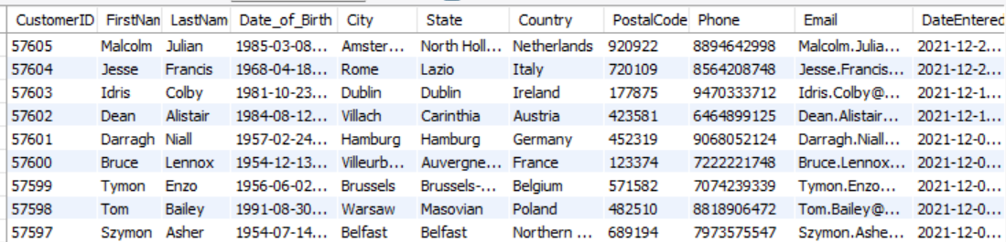

Q2. **Print details of orders which have total order amount between 10000 and 20000 (both inclusive).Sort your output in ascending order of OrderID.**

Required Output:

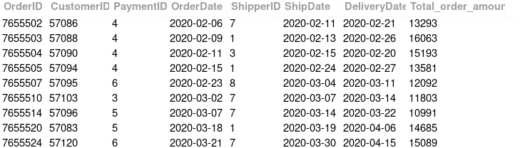

Q3. **Print all details of Suppliers whose details are stored in the database.**

**Sort the result in Alphabetical order of Company Name.**

Sample Output:

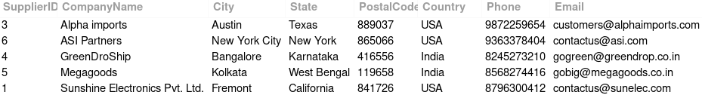

Q4. **Print the customers details who are from Bremen City.**  
**Sort the output on ascending order of Customer Id.**

Sample Output -



Q5. **Print details of all the products whose brand name is BB combo.**

**Sort the order in ascending order of Sub Category, if there are same Sub Categories then sort by Product Id in ascending order.**

Sample Output:

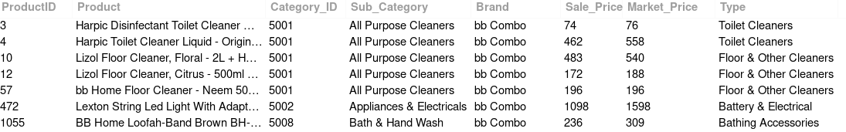

ASSIGNMENT – 2

**Q1. Print the Customers table, order output in descending order of CustomerID.**

Sample Output



Q2. **Print details of orders which have total order amount between 10000 and 20000 (both inclusive).Sort your output in ascending order of OrderID.**

Required Output:



Q3. **Print all details of Suppliers whose details are stored in the database.**

**Sort the result in Alphabetical order of Company Name.**

Sample Output:



Q4. **Print the customers details who are from Bremen City.**  
**Sort the output on ascending order of Customer Id.**

Sample Output -



Q5. **Print details of all the products whose brand name is BB combo.**

**Sort the order in ascending order of Sub Category, if there are same Sub Categories then sort by Product Id in ascending order.**

Sample Output:



ASSIGNMENT – 3

Q1. **Print all details of Orders which either have Total Order Amount less than 5000 or which were shipped by shipper with ID 2.**

**Sort your output in ascending order of OrderID.**

Sample Output:

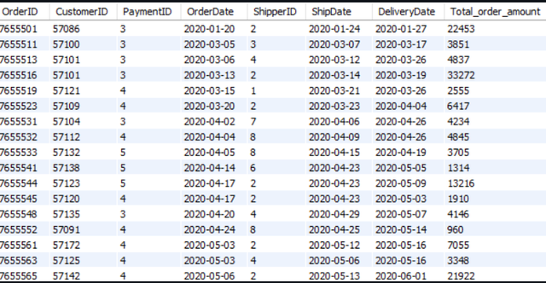

Q2. **Identify Customers whose FirstNames start with the letter K.**

**Print all details of these customers.**

**Sort the result set in ascending order of CustomerID.**

Sample Output -

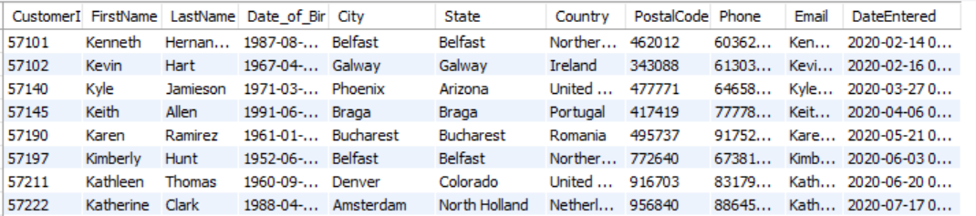

Q3. **Identify Customers in the database whose first name starts with the letter H and last name starts with the letter W.**

**Print all details of these customers.**

**Sort the result set in ascending order of CustomerID.**

Q4. **Identify Customers in the database whose first name does not start with the letter H but last name starts with the letter W.**

**Print all details of these customers.**

**Sort the result set in ascending order of CustomerID.**

Sample Output -

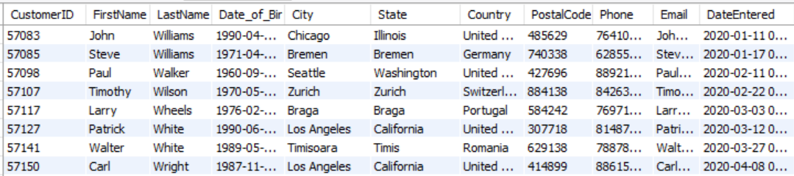

Q5. **Print the average order amount for orders which were paid for using payment method with ID 3.**

**Q6. Print all details of Orders which were placed by Customers whose ID is a multiple of 10, payment method by Payment with ID 4, shipped by Shipper with ID 3 and which are greater than 30,000 in order value.**

**Sort the result set in descending order of Customer ID.**

**Sample Output**

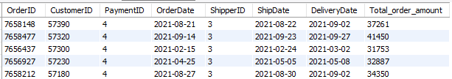

Q7. **Print the Total Revenue Generated and the Average Order Amount of orders which were paid with payment method 5 and were shipped by shipper with ID 1.**

**You need to print 2 columns in the output - 1 for the Total Revenue Generated, 1 for the Average Order Amount.**

Q8. **Create an email of each customer as**[**customerid@masai.com**](mailto:customerid@masai.com)**. So for customer with ID 500, his ID should be created as '**[**500@masai.com**](mailto:500@masai.com)**'.**

**Print CustomerID, First Name, Last Name and the newly created email address.**

**Sort the result in ascending order of CustomerID.**

Sample Output -

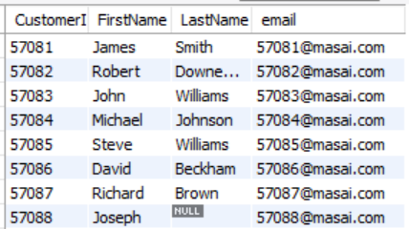

Database Schema:

Q9. **Print the total Market price of products whose Category ID equal to 5011.**

**Q10. Print all unique brand name where type is "Air Freshener".**  
**Sort the ouput in ascending order.**

Sample Output -

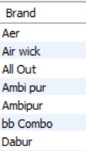

Q11. **Find the number of customers who placed the order in first month of year 2021.**

**Q12. Print all the details of table Order Details with Quantity more than 19.**

**Sort the output in ascending order of Order Detail Id.**

Sample Output:

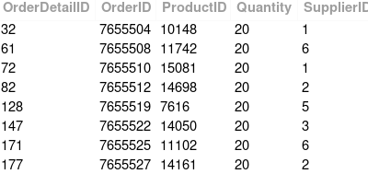

Q12. **Print all Product Name where type is "Imported Cleaners" and Market Price is more than 400.**

**Sort the Product Name in ascending order.**

Sample Output:

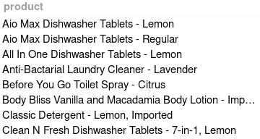

Q13. **We are writing an API that shows all the customerData in series of pages.**

**Each page contains 5 customers**

**Output the Customer data that will be displayed on 6th page**

**Expected Output :**

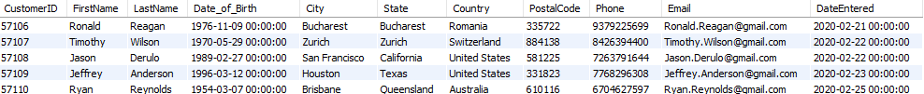

ASSIGNMENT – 4

Q1. **Print the total revenue made by the company which was received through Payment Id - 2.**

**(Use Total_Order_Amount to calculate revenue)**

**Q2. Print the first and the last order dates on which the orders were placed as stored in the database.**

**Sample Output:**

image

Q3. **Print the least order amount placed by any customer.**

**Q4. Print all details of Customers whose first names do not start with Vowels.**

**Sort the result in ascending order of CustomerID.**

Sample Output -

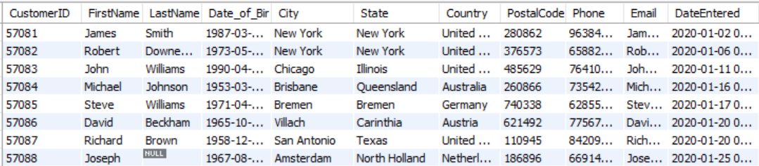

Q5. **Print all details of Customers whose first names start with a Vowel and Phone Number starts with 9.**

**Sort the result in ascending order of CustomerID.**

Sample Output -

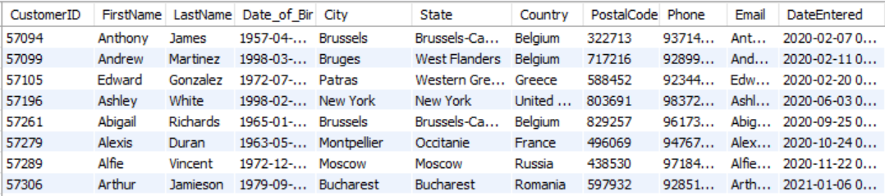

Q6. **Print the count of Orders whose Total_order_Amount value is an even number.**

**Q7. Print the unique Last names of customers whose details are stored in the database.**

**Sort the result set in reverse alphabetical order of the Last names.**

Sample Output:

[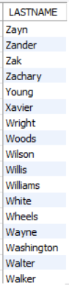](https://cp.masaischool.com/assignments/3076/pi/7/solve)

Q8. **Print ProductID and the combination of Brand Name and Product Name.**

**The Brand Name and the Product Name should be separated by a space, an hyphen, followed by another space.**

**Sort the result set in ascending order of ProductID.**

Sample Output -

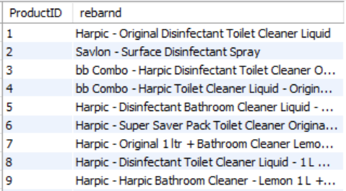

Q9. **What is the phone number of customer whose firstname is Ezra and lastname is Duncan**

Q10. **Print the following Table:**

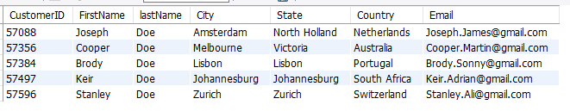

**The table identifies the customers who do not have a last name stored in the database.**

**For such customers, you are then required to put 'Doe' as their last name along with the other details.**

**Sort the result in ascending order of CustomerID.**

Q11. **Print the customer ID, first name, last name, and the month name of their date of birth from the customers table. Sort the results by customer ID in ascedning order.**

Sample Output -

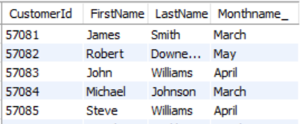

Q12. **We are working on a page that shows all the details in OrderDetails table with 10 rows in each page.**

**For example, if you use limit 10,10 it will return records 11 to 20 depending on orderby condition**

**Sorting should be done on OrderDetailID and then OrderID in ascending order, Display the records on 10th page**

Q13. **Print all details of orders which were ordered on the 16th of December 2021 and were paid through using payment with ID 4.**

**Sort the result in ascending order of OrderID.**

Sample Output -

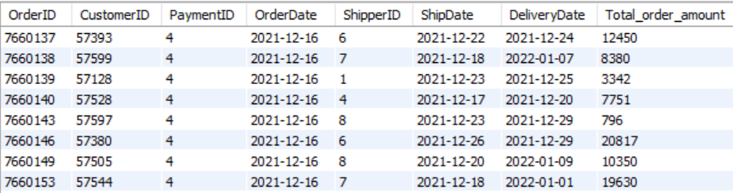

Q14. **Print all details of Products where there is no discount offered (consider looking at their Sale_price and Market_price values) and whose sale price is greater than 2500.**

**Sort the result in ascending order of ProductID.**

**Sample Output**

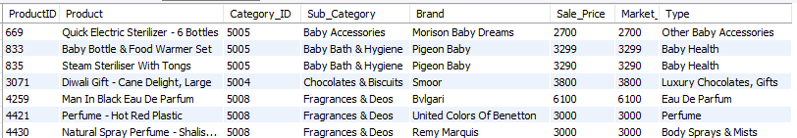

ASSIGIMENT – 5

Q1. **Find the Number of Customers belonging to each Country.**

**Print the Country column first followed by the Number of Customers belonging to each Country in the second column.**

**Sort the result in alphabetical order of Country Names.**

Sample Output:

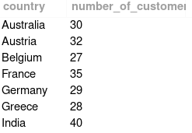

Q2. **Get the Total Quantity of products ordered for each order.**

**Print the columns Order ID and Total Quantity in the output.**

**Sort the result set in ascending order of Order ID.**

Sample Output:

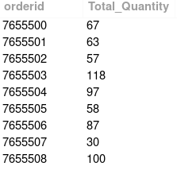

Q3. **Get the total number of records for each Brand.**

**Print the Brand name in alphabetical order in the first column followed by number of products for respective brands in second column.**

Sample Output -

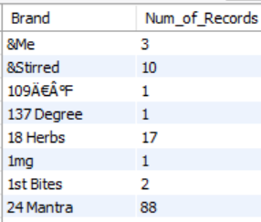

Q4. **Get the maximum Market Price of products for each Type.**

**Print the Type in alphabetical order in the first column, followed by the maximum Market Price in the second column.**

**Sample Output:**

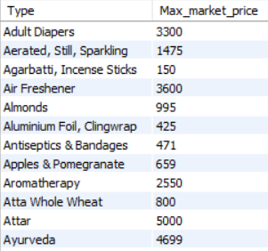

Q5. **Calculate the total quantity of products per order irrespective of ProductID for each order.**

**Print OrderID and Total Order Quantity.**

**Filter to only print orders which have total quantity greater than 100.**

**Sort the result set in ascending order of OrderID.**

Q6. **Calculate the total product quantity supplied by each supplier.**

**Print Supplier ID and Total Quantity.**

**Filter to only print Suppliers who shipped more than 48000 in quantity.**

**Sort the result set in ascending order of SupplierID.**

Q7. **Print the average spend per order and the total spend across all orders, made by Customer with ID 57100.**

Sample Output - (Numbers are not actual.)

image

Q8. **Find the average Total order amount for each shippers and each Total order amount should be divisible by 550.**

**Sort the output in decreasing order of Shipper ID.**

**Sample Output**

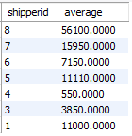

Q9. **Find the sum of the total order amount for each shipper whose ShipperID is the same as the PaymentID.**

**In the output, print the ShipperID and the sum of the total amount.**

**Sort the output in increasing order based on the ShipperID.**

Smaple Output -

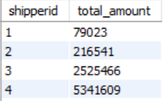

Q10. **Find the total amount for each shippers whose Customer ID is divisible by Payment ID.**

**Print Shipper ID and total amount.**

**Hint: take Total order amount for finding the total amount.**

**Sort the output in increasing order of Shipper ID.**

**Sample Output**

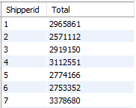

ASSIGIMENT – 6

Q1. **Count the number of Customers from Germany**

Q2. **Get the average Market Price across combinations of each Brand and Type.**

**Print Brand in first column, Type in second column, followed by corresponding average Market Price in the third column.**

**Sort the result set in alphabetical order of Brand, for rows with same Brand, sort them in alphabetical order of Type.**

**Sample Output:**

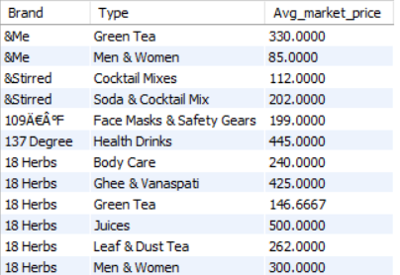

Q3. **Identify the number of orders placed in each month of the year 2021.**

**Print Month followed by Number of Orders.**

**Sort the result set in ascending order of Month.**

Sample Output:

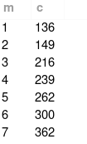

Q4. **Identify the Month-Year combination which had the Highest Customer Acquisition.**

**Print Month, Year, Number of Customers whose details were entered into the database.**

**NOTE : Ouput has only one line**

Q5. **Print the Month number and number of orders ordered in that particular month for each of the months of the year 2020.**

**Consider the dates from OrderDate for this calculation.**

**Print for only those months where the number of orders placed is less than 100.**

**Sort the result set in ascending order of Month number.**

**Use MONTH( Relevant_Column ) and YEAR( Relevant_Column ) to extract the month and year from the given date column for generating the result set.**

**Sample Output**

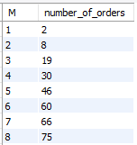

Q6. **Identify and print top three months where the most number of orders were delivered across both the years 2020 and 2021.**

**Print Month Number, Month Name, followed by the order count.**

**Sort the result in descending order of Count.**

Sample Output -

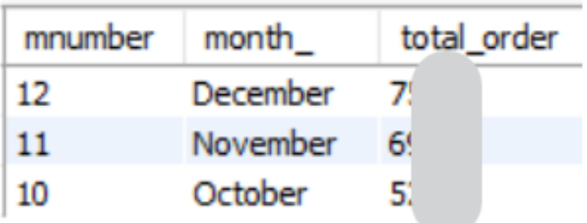

Q7. **Identify the count of orders Shipped in each of the first 6 months of 2021.**

**Print the month name followed by the count of orders.**

**Sort the result in descending order of Count.**

Sample Output:

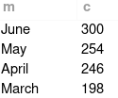

Q8. **Print the following table which depicts the length of first names in the customers table along with the corresponding count of such names.**

**Sort the result in ascending order of Length of FirstNames.**

Required Result:

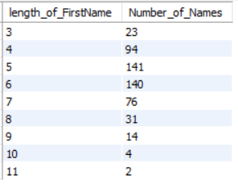

Q9. **Write a query to calculate the total Sale price for each Category that has an even Category ID.**

**Sort your output in increasing order of Category ID.**

**Sample Output**

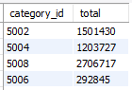

Q10. **Write a query to calculate the total count of unique Product IDs for each order in the Orderdetails table, where the count of unique Product IDs is exactly 5.**

**Print Order Id and total count.**

**Sort the output in ascending order of Order ID.**

**Sample Output**

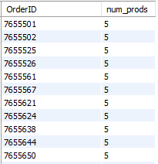

Q11. **Get the sum of the Total order amount for each shipper for all Orders whose Total order amount would be greater than 12500.**

**Sort the output in increasing order of Shipper ID.**

**Sample Output**

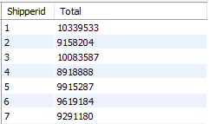

Q12. **Print the days of the week(Sunday , Monday ...) ,the average order amount for that day, and the total number of orders placed on that day.**

**Order the output in descending order of average order amount.**

**Sample output:**

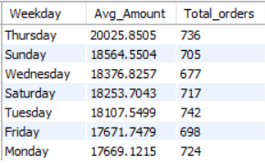

Q13. **Print the brand names and total number of products of those brands currently selling at a discount of more than 50%. Sort the table in descending order based on the number of products and in ascending order based on the brand names.**

Smaple Output -

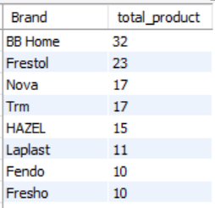

Q14. **The stakeholders wants to know about those 5 Sub categories who has the most products with no discount (consider looking at their Sale_price and Market_price values).**

**Give Sub Category name and total products with no discount.**

**Sort the result in descending order of total Product.**

Sample Output :

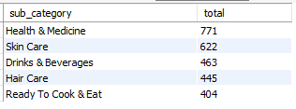

Q15. **What is the number of customer acquisitions for each month in the year 2021?**

**Print the month number and the count of customer acquisitions. Sort the table in ascending order by month.**

Sample Output -

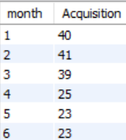

ASSIGNMENT – 6

Q1. **Print all the unique City names the customers belong to, order output in alphabetical order of City name.**

**Sample Output:**

[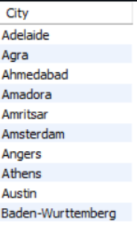](https://imgbb.com/)

Q2. **Print all details of products whose Market price is greater than 2000.**

**Sort the output in ascending order of Product ID.**

**Sample Output**

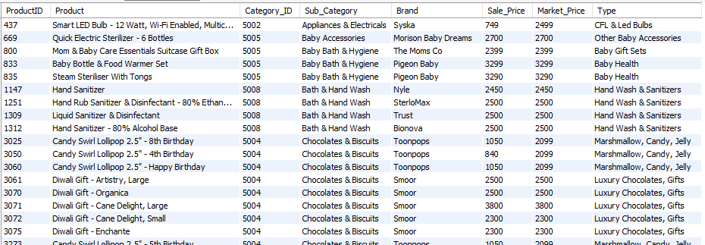

Q3. **Get the city and states which have less than 3 customers.**

**Print City, State and Count of customers who belong to that city.**

**Sort the result set in alphabetical order of City names.**

**Sample output:**

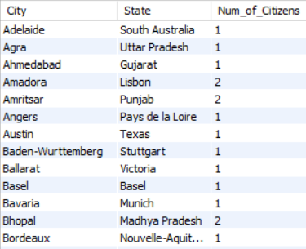

Q4. **Get the minimum Sale price of products for each Sub Category.**

**Print the Sub Category in alphabetical order in the first column, followed by corresponding minimum Sale price in the second column.**

**Sample Output:**

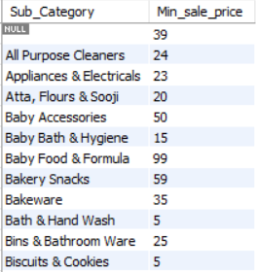

Q5. **Identify the Average Order Amount by each Customer in each Month of Year 2020.**

**Print Customer ID, Month, Average Order Amount.**

**Sort the result set in ascending order of Customer ID.**

**For records with the same Customer ID - sort them in ascending order of Month.**

Sample Output:

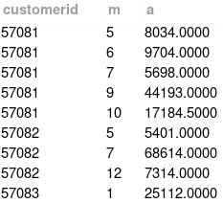

Q6. **Identify Unique First Names of Customers in the database. Print Count of these FirstNames in the output.**

Q7. **Print the highest and the lowest order amounts in the database.**

Q8. **Calculate the average sale price of products sold by each brand.**

**Print Brand, Average Sale Price of Products.**

**Filter to only print Brands whose average sale price of Products is greater than 1000.**

**Sort the result in alphabetical order of Brand Name.**

Q9. **Print CustomerID, First Name, Last Name, City, Email and Phone number of Customers whose Phone number starts with the digit 9 and ends with the digit 8.**

**Sort the output on ascending order of CustomerID.**

Sample Output -

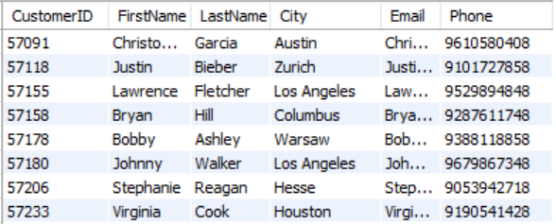

Q10. **Print the average sale price and the average market price of products produced by the Brand Fresho.**

Q11. **Categorize the Customers into 2 classes based on Year of Birth.**

**'Old' - when the Year of Birth is less than 1995.**

**'Young' - when the Year of Birth is greater than or equal to 1995.**

**Print CustomerID, FirstName, LastName and the new classification.**

**Sort the result set in ascending order of CustomerID.**

**Sample Output:**

Q12. **Print all the columns from the Orders table except the PaymentID and ShipperID Columns, and follow the same order in which the columns are arranged in the table.**

**Filter your records to include only those customers whose CustomerID is a multiple of 5.**

**Order your output in ascending order of OrderID.**

Q13. **Identify the number of phone numbers in the database that start with the digits 6,7,8 and 9.**

**Print the start digit (6,7,8,9) in the first column, followed by the count in the second column.**

**Sort the result in ascending order count.**

Q14. P**rint all product details from the 'products' table and add an additional column named 'discount' which represents the difference between the market price and the sale price.**

**Sort the table in descending order based on the 'discount' column and ascedning order based on Product Id .**

**Expected Output :**

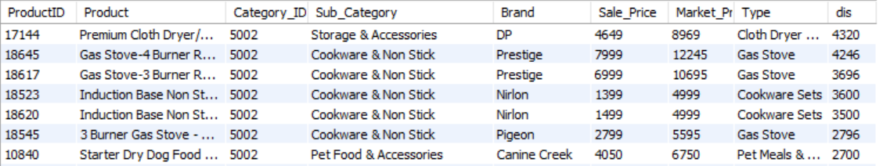

Q15. **What is the total order amount for each payment method in each year?**  
**Print the year, payment ID, and the sum of the total order amount for each combination of year and payment ID.**  
**Sort the results in ascending order based on the year, and within each year, sort the payment IDs in ascending order as well.**

Sample Output -

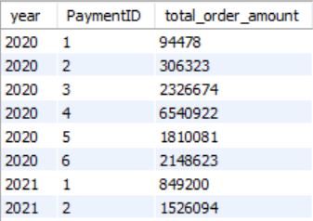

Q16. **What is the list of order dates and their corresponding sum of total order amounts from the orders table where the sum of total order amount is greater than the maximum total order amount of any other order date plus 5000? The results should be sorted in descending order by order date.**

**Hint: Take total order amount column to finding amounts.**

**Sample Output**

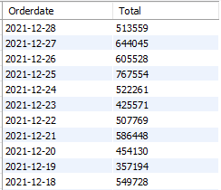

Q17.

[Description](https://cp.masaischool.com/assignments/3083/pi/17/solve" \l "description)

[Submissions](https://cp.masaischool.com/assignments/3083/pi/17/solve" \l "submissions)

**Print every detail from the Order Details table.**

**Sort the output in descending order of Order Detail Id.**

Sample Output:

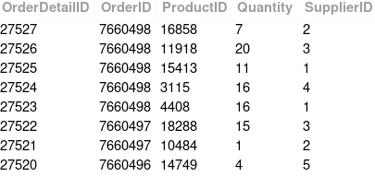

Q18. **Identify the number of phone numbers in the database that start with the digits 6,7,8 and 9.**

**Print the start digit (6,7,8,9) in the first column, followed by the count in the second column.**

**Sort the result in ascending order count.**

Q19. P**rint all product details from the 'products' table and add an additional column named 'discount' which represents the difference between the market price and the sale price.**

**Sort the table in descending order based on the 'discount' column and ascedning order based on Product Id .**

**Expected Output :**



Q20. **What is the total order amount for each payment method in each year?**  
**Print the year, payment ID, and the sum of the total order amount for each combination of year and payment ID.**  
**Sort the results in ascending order based on the year, and within each year, sort the payment IDs in ascending order as well.**

Sample Output -



Q21. **What is the list of order dates and their corresponding sum of total order amounts from the orders table where the sum of total order amount is greater than the maximum total order amount of any other order date plus 5000? The results should be sorted in descending order by order date.**

**Hint: Take total order amount column to finding amounts.**

**Sample Output**



Q22. **Print every detail from the Order Details table.**

**Sort the output in descending order of Order Detail Id.**

Sample Output:



Q23. **You have decided to sell the Products of the Sub Category 'Stationery' whose sale price is greater than 200, at a new Price.**

**Let the new price be calculated as the multiplication of the Sale Price and Market Price divided by the Sum of the two prices.**

**Print ProductId, Product Name, Sub_category, Sale Price, Market Price, and the new price.**

**Sort the result in ascending order of ProductID.**

Sample Output -

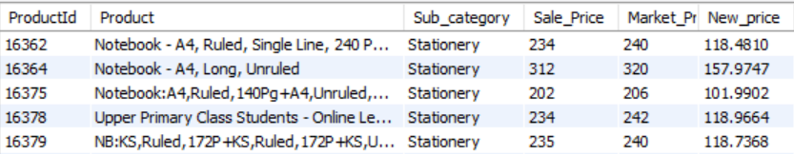

Q24. **Calculate the Average Order Amount and Sum of the Order Amounts of all orders which were Shipped by Shipper with ID 1 and Paid for by using Payment with ID 3.**

**Print the Average Order Amount in the first Column, Sum of the Order Amounts in the second Column.**

Q25. **Print OrderID, CustomerID, PaymentID, OrderDate and order amount of orders paid for by using Credit Cards and whose order amount is between 100 and 1000 bucks (both values inclusive).**

**Sort the result in ascending order of OrderID.**

**Identify the PaymentID of Credit Card payment method by looking at the Payments Table.**

Sample Output:

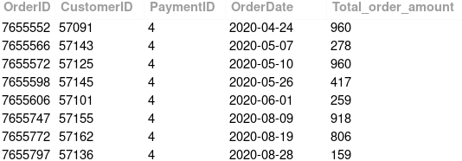

ASSIGNMENT – 7

Q1.

Q2.

Q3.

Q4.

Q5.

Q6.

Q7.

Q8.

Q9.

Q10.

Q11.

Q12.

Q13.

Q14.

Q15.

Q16.

Q17.

ASSIGNMENT - 1

Q1. **Print the Customers table, order output in descending order of CustomerID.**

Sample Output



Q2. **Print details of orders which have total order amount between 10000 and 20000 (both inclusive).Sort your output in ascending order of OrderID.**

Required Output:



Q3. **Print all details of Suppliers whose details are stored in the database.**

**Sort the result in Alphabetical order of Company Name.**

Sample Output:



Q4. **Print the customers details who are from Bremen City.**  
**Sort the output on ascending order of Customer Id.**

Sample Output -



Q5. **Print details of all the products whose brand name is BB combo.**

**Sort the order in ascending order of Sub Category, if there are same Sub Categories then sort by Product Id in ascending order.**

Sample Output:



ASSIGNMENT – 2

**Q1. Print the Customers table, order output in descending order of CustomerID.**

Sample Output



Q2. **Print details of orders which have total order amount between 10000 and 20000 (both inclusive).Sort your output in ascending order of OrderID.**

Required Output:



Q3. **Print all details of Suppliers whose details are stored in the database.**

**Sort the result in Alphabetical order of Company Name.**

Sample Output:



Q4. **Print the customers details who are from Bremen City.**  
**Sort the output on ascending order of Customer Id.**

Sample Output -



Q5. **Print details of all the products whose brand name is BB combo.**

**Sort the order in ascending order of Sub Category, if there are same Sub Categories then sort by Product Id in ascending order.**

Sample Output:



ASSIGNMENT – 3

Q1. **Print all details of Orders which either have Total Order Amount less than 5000 or which were shipped by shipper with ID 2.**

**Sort your output in ascending order of OrderID.**

Sample Output:



Q2. **Identify Customers whose FirstNames start with the letter K.**

**Print all details of these customers.**

**Sort the result set in ascending order of CustomerID.**

Sample Output -



Q3. **Identify Customers in the database whose first name starts with the letter H and last name starts with the letter W.**

**Print all details of these customers.**

**Sort the result set in ascending order of CustomerID.**

Q4. **Identify Customers in the database whose first name does not start with the letter H but last name starts with the letter W.**

**Print all details of these customers.**

**Sort the result set in ascending order of CustomerID.**

Sample Output -



Q5. **Print the average order amount for orders which were paid for using payment method with ID 3.**

**Q6. Print all details of Orders which were placed by Customers whose ID is a multiple of 10, payment method by Payment with ID 4, shipped by Shipper with ID 3 and which are greater than 30,000 in order value.**

**Sort the result set in descending order of Customer ID.**

**Sample Output**



Q7. **Print the Total Revenue Generated and the Average Order Amount of orders which were paid with payment method 5 and were shipped by shipper with ID 1.**

**You need to print 2 columns in the output - 1 for the Total Revenue Generated, 1 for the Average Order Amount.**

Q8. **Create an email of each customer as**[**customerid@masai.com**](mailto:customerid@masai.com)**. So for customer with ID 500, his ID should be created as '**[**500@masai.com**](mailto:500@masai.com)**'.**

**Print CustomerID, First Name, Last Name and the newly created email address.**

**Sort the result in ascending order of CustomerID.**

Sample Output -



Database Schema:

Q9. **Print the total Market price of products whose Category ID equal to 5011.**

**Q10. Print all unique brand name where type is "Air Freshener".**  
**Sort the ouput in ascending order.**

Sample Output -



Q11. **Find the number of customers who placed the order in first month of year 2021.**

**Q12. Print all the details of table Order Details with Quantity more than 19.**

**Sort the output in ascending order of Order Detail Id.**

Sample Output:



Q12. **Print all Product Name where type is "Imported Cleaners" and Market Price is more than 400.**

**Sort the Product Name in ascending order.**

Sample Output:



Q13. **We are writing an API that shows all the customerData in series of pages.**

**Each page contains 5 customers**

**Output the Customer data that will be displayed on 6th page**

**Expected Output :**



ASSIGNMENT – 4

Q1. **Print the total revenue made by the company which was received through Payment Id - 2.**

**(Use Total_Order_Amount to calculate revenue)**

**Q2. Print the first and the last order dates on which the orders were placed as stored in the database.**

**Sample Output:**

image

Q3. **Print the least order amount placed by any customer.**

**Q4. Print all details of Customers whose first names do not start with Vowels.**

**Sort the result in ascending order of CustomerID.**

Sample Output -



Q5. **Print all details of Customers whose first names start with a Vowel and Phone Number starts with 9.**

**Sort the result in ascending order of CustomerID.**

Sample Output -



Q6. **Print the count of Orders whose Total_order_Amount value is an even number.**

**Q7. Print the unique Last names of customers whose details are stored in the database.**

**Sort the result set in reverse alphabetical order of the Last names.**

Sample Output:

[](https://cp.masaischool.com/assignments/3076/pi/7/solve)

Q8. **Print ProductID and the combination of Brand Name and Product Name.**

**The Brand Name and the Product Name should be separated by a space, an hyphen, followed by another space.**

**Sort the result set in ascending order of ProductID.**

Sample Output -



Q9. **What is the phone number of customer whose firstname is Ezra and lastname is Duncan**

Q10. **Print the following Table:**



**The table identifies the customers who do not have a last name stored in the database.**

**For such customers, you are then required to put 'Doe' as their last name along with the other details.**

**Sort the result in ascending order of CustomerID.**

Q11. **Print the customer ID, first name, last name, and the month name of their date of birth from the customers table. Sort the results by customer ID in ascedning order.**

Sample Output -



Q12. **We are working on a page that shows all the details in OrderDetails table with 10 rows in each page.**

**For example, if you use limit 10,10 it will return records 11 to 20 depending on orderby condition**

**Sorting should be done on OrderDetailID and then OrderID in ascending order, Display the records on 10th page**

Q13. **Print all details of orders which were ordered on the 16th of December 2021 and were paid through using payment with ID 4.**

**Sort the result in ascending order of OrderID.**

Sample Output -



Q14. **Print all details of Products where there is no discount offered (consider looking at their Sale_price and Market_price values) and whose sale price is greater than 2500.**

**Sort the result in ascending order of ProductID.**

**Sample Output**



ASSIGIMENT – 5

Q1. **Find the Number of Customers belonging to each Country.**

**Print the Country column first followed by the Number of Customers belonging to each Country in the second column.**

**Sort the result in alphabetical order of Country Names.**

Sample Output:



Q2. **Get the Total Quantity of products ordered for each order.**

**Print the columns Order ID and Total Quantity in the output.**

**Sort the result set in ascending order of Order ID.**

Sample Output:



Q3. **Get the total number of records for each Brand.**

**Print the Brand name in alphabetical order in the first column followed by number of products for respective brands in second column.**

Sample Output -



Q4. **Get the maximum Market Price of products for each Type.**

**Print the Type in alphabetical order in the first column, followed by the maximum Market Price in the second column.**

**Sample Output:**



Q5. **Calculate the total quantity of products per order irrespective of ProductID for each order.**

**Print OrderID and Total Order Quantity.**

**Filter to only print orders which have total quantity greater than 100.**

**Sort the result set in ascending order of OrderID.**

Q6. **Calculate the total product quantity supplied by each supplier.**

**Print Supplier ID and Total Quantity.**

**Filter to only print Suppliers who shipped more than 48000 in quantity.**

**Sort the result set in ascending order of SupplierID.**

Q7. **Print the average spend per order and the total spend across all orders, made by Customer with ID 57100.**

Sample Output - (Numbers are not actual.)

image

Q8. **Find the average Total order amount for each shippers and each Total order amount should be divisible by 550.**

**Sort the output in decreasing order of Shipper ID.**

**Sample Output**



Q9. **Find the sum of the total order amount for each shipper whose ShipperID is the same as the PaymentID.**

**In the output, print the ShipperID and the sum of the total amount.**

**Sort the output in increasing order based on the ShipperID.**

Smaple Output -



Q10. **Find the total amount for each shippers whose Customer ID is divisible by Payment ID.**

**Print Shipper ID and total amount.**

**Hint: take Total order amount for finding the total amount.**

**Sort the output in increasing order of Shipper ID.**

**Sample Output**



ASSIGIMENT – 6

Q1. **Count the number of Customers from Germany**

Q2. **Get the average Market Price across combinations of each Brand and Type.**

**Print Brand in first column, Type in second column, followed by corresponding average Market Price in the third column.**

**Sort the result set in alphabetical order of Brand, for rows with same Brand, sort them in alphabetical order of Type.**

**Sample Output:**



Q3. **Identify the number of orders placed in each month of the year 2021.**

**Print Month followed by Number of Orders.**

**Sort the result set in ascending order of Month.**

Sample Output:



Q4. **Identify the Month-Year combination which had the Highest Customer Acquisition.**

**Print Month, Year, Number of Customers whose details were entered into the database.**

**NOTE : Ouput has only one line**

Q5. **Print the Month number and number of orders ordered in that particular month for each of the months of the year 2020.**

**Consider the dates from OrderDate for this calculation.**

**Print for only those months where the number of orders placed is less than 100.**

**Sort the result set in ascending order of Month number.**

**Use MONTH( Relevant_Column ) and YEAR( Relevant_Column ) to extract the month and year from the given date column for generating the result set.**

**Sample Output**



Q6. **Identify and print top three months where the most number of orders were delivered across both the years 2020 and 2021.**

**Print Month Number, Month Name, followed by the order count.**

**Sort the result in descending order of Count.**

Sample Output -



Q7. **Identify the count of orders Shipped in each of the first 6 months of 2021.**

**Print the month name followed by the count of orders.**

**Sort the result in descending order of Count.**

Sample Output:



Q8. **Print the following table which depicts the length of first names in the customers table along with the corresponding count of such names.**

**Sort the result in ascending order of Length of FirstNames.**

Required Result:



Q9. **Write a query to calculate the total Sale price for each Category that has an even Category ID.**

**Sort your output in increasing order of Category ID.**

**Sample Output**



Q10. **Write a query to calculate the total count of unique Product IDs for each order in the Orderdetails table, where the count of unique Product IDs is exactly 5.**

**Print Order Id and total count.**

**Sort the output in ascending order of Order ID.**

**Sample Output**



Q11. **Get the sum of the Total order amount for each shipper for all Orders whose Total order amount would be greater than 12500.**

**Sort the output in increasing order of Shipper ID.**

**Sample Output**



Q12. **Print the days of the week(Sunday , Monday ...) ,the average order amount for that day, and the total number of orders placed on that day.**

**Order the output in descending order of average order amount.**

**Sample output:**



Q13. **Print the brand names and total number of products of those brands currently selling at a discount of more than 50%. Sort the table in descending order based on the number of products and in ascending order based on the brand names.**

Smaple Output -



Q14. **The stakeholders wants to know about those 5 Sub categories who has the most products with no discount (consider looking at their Sale_price and Market_price values).**

**Give Sub Category name and total products with no discount.**

**Sort the result in descending order of total Product.**

Sample Output :



Q15. **What is the number of customer acquisitions for each month in the year 2021?**

**Print the month number and the count of customer acquisitions. Sort the table in ascending order by month.**

Sample Output -



ASSIGNMENT – 6

Q1. **Print all the unique City names the customers belong to, order output in alphabetical order of City name.**

**Sample Output:**

[](https://imgbb.com/)

Q2. **Print all details of products whose Market price is greater than 2000.**

**Sort the output in ascending order of Product ID.**

**Sample Output**



Q3. **Get the city and states which have less than 3 customers.**

**Print City, State and Count of customers who belong to that city.**

**Sort the result set in alphabetical order of City names.**

**Sample output:**



Q4. **Get the minimum Sale price of products for each Sub Category.**

**Print the Sub Category in alphabetical order in the first column, followed by corresponding minimum Sale price in the second column.**

**Sample Output:**



Q5. **Identify the Average Order Amount by each Customer in each Month of Year 2020.**

**Print Customer ID, Month, Average Order Amount.**

**Sort the result set in ascending order of Customer ID.**

**For records with the same Customer ID - sort them in ascending order of Month.**

Sample Output:



Q6. **Identify Unique First Names of Customers in the database. Print Count of these FirstNames in the output.**

Q7. **Print the highest and the lowest order amounts in the database.**

Q8. **Calculate the average sale price of products sold by each brand.**

**Print Brand, Average Sale Price of Products.**

**Filter to only print Brands whose average sale price of Products is greater than 1000.**

**Sort the result in alphabetical order of Brand Name.**

Q9. **Print CustomerID, First Name, Last Name, City, Email and Phone number of Customers whose Phone number starts with the digit 9 and ends with the digit 8.**

**Sort the output on ascending order of CustomerID.**

Sample Output -



Q10. **Print the average sale price and the average market price of products produced by the Brand Fresho.**

Q11. **Categorize the Customers into 2 classes based on Year of Birth.**

**'Old' - when the Year of Birth is less than 1995.**

**'Young' - when the Year of Birth is greater than or equal to 1995.**

**Print CustomerID, FirstName, LastName and the new classification.**

**Sort the result set in ascending order of CustomerID.**

**Sample Output:**

Q12. **Print all the columns from the Orders table except the PaymentID and ShipperID Columns, and follow the same order in which the columns are arranged in the table.**

**Filter your records to include only those customers whose CustomerID is a multiple of 5.**

**Order your output in ascending order of OrderID.**

Q13. **Identify the number of phone numbers in the database that start with the digits 6,7,8 and 9.**

**Print the start digit (6,7,8,9) in the first column, followed by the count in the second column.**

**Sort the result in ascending order count.**

Q14. P**rint all product details from the 'products' table and add an additional column named 'discount' which represents the difference between the market price and the sale price.**

**Sort the table in descending order based on the 'discount' column and ascedning order based on Product Id .**

**Expected Output :**



Q15. **What is the total order amount for each payment method in each year?**  
**Print the year, payment ID, and the sum of the total order amount for each combination of year and payment ID.**  
**Sort the results in ascending order based on the year, and within each year, sort the payment IDs in ascending order as well.**

Sample Output -



Q16. **What is the list of order dates and their corresponding sum of total order amounts from the orders table where the sum of total order amount is greater than the maximum total order amount of any other order date plus 5000? The results should be sorted in descending order by order date.**

**Hint: Take total order amount column to finding amounts.**

**Sample Output**



Q17.

[Description](https://cp.masaischool.com/assignments/3083/pi/17/solve" \l "description)

[Submissions](https://cp.masaischool.com/assignments/3083/pi/17/solve" \l "submissions)

**Print every detail from the Order Details table.**

**Sort the output in descending order of Order Detail Id.**

Sample Output:



Q18. **Identify the number of phone numbers in the database that start with the digits 6,7,8 and 9.**

**Print the start digit (6,7,8,9) in the first column, followed by the count in the second column.**

**Sort the result in ascending order count.**

Q19. P**rint all product details from the 'products' table and add an additional column named 'discount' which represents the difference between the market price and the sale price.**

**Sort the table in descending order based on the 'discount' column and ascedning order based on Product Id .**

**Expected Output :**



Q20. **What is the total order amount for each payment method in each year?**  
**Print the year, payment ID, and the sum of the total order amount for each combination of year and payment ID.**  
**Sort the results in ascending order based on the year, and within each year, sort the payment IDs in ascending order as well.**

Sample Output -



Q21. **What is the list of order dates and their corresponding sum of total order amounts from the orders table where the sum of total order amount is greater than the maximum total order amount of any other order date plus 5000? The results should be sorted in descending order by order date.**

**Hint: Take total order amount column to finding amounts.**

**Sample Output**



Q22. **Print every detail from the Order Details table.**

**Sort the output in descending order of Order Detail Id.**

Sample Output:



Q23. **You have decided to sell the Products of the Sub Category 'Stationery' whose sale price is greater than 200, at a new Price.**

**Let the new price be calculated as the multiplication of the Sale Price and Market Price divided by the Sum of the two prices.**

**Print ProductId, Product Name, Sub_category, Sale Price, Market Price, and the new price.**

**Sort the result in ascending order of ProductID.**

Sample Output -



Q24. **Calculate the Average Order Amount and Sum of the Order Amounts of all orders which were Shipped by Shipper with ID 1 and Paid for by using Payment with ID 3.**

**Print the Average Order Amount in the first Column, Sum of the Order Amounts in the second Column.**

Q25. **Print OrderID, CustomerID, PaymentID, OrderDate and order amount of orders paid for by using Credit Cards and whose order amount is between 100 and 1000 bucks (both values inclusive).**

**Sort the result in ascending order of OrderID.**

**Identify the PaymentID of Credit Card payment method by looking at the Payments Table.**

Sample Output:



ASSIGNMENT – 7

Q1. **dentify top 10 most expensive orders.**

**Identify the customers who placed these orders.**

**Print Customer ID, First Name, Last Name and Total Order amount in the result set.**

**Sort the result set in descending order of Total Order Amount.**

**Sample Output**

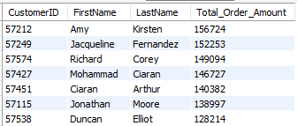

Q2. **Print Order ID, Customer ID, First Name, Email and Total Order Amount for all orders placed.**

**Sort the result in ascending order of Order ID.**

**Sample Output**

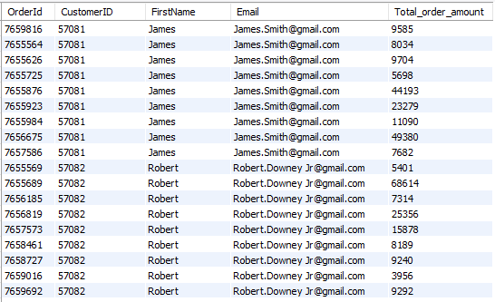

Q3. **Print OrderDetailID, OrderID, Supplier Name, ProductID, and Quantity of all data points from the relevant tables.**

**Sort the result in ascending order of OrderDetailID.**

Q4. **Print Order ID, Customer ID, Payment Type, and Total Order Amount for all orders paid through a card payment type.**

**Sort the result in ascending order of Order ID**

**Sample Output**

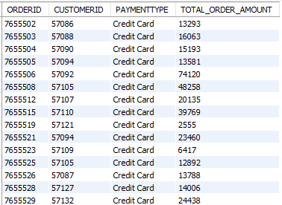

Q5. **Print pairs of supplier companies that established in the same country.**

**Print name of first company, name of second company, country name.**

**For example is company ABC and Company DEF are from India, the output will look like ABC, DEF, India.**

**Sort the result set in alphabetical order of company names in the first column and if the companyname is same then consider second company name in ascending order.**

Sample Output -

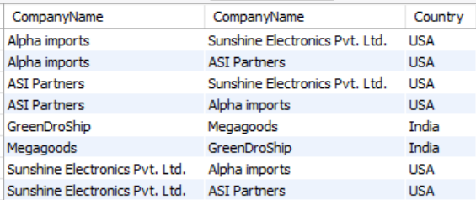

Q6. **Identify and print pairs of products which have the same sale price. Print the names of the products with same sale price in the first two columns, followed by the sale price. Filter to identify only pairs of products whose sale price is greater than 5500 bucks. Sort the result in alphabetical order of products names in the first column and alphabetical order of products names in the second column.**

Q7. **Print all customerID and OrderId where total order amount is less than 100.**

**Sort the output in increasing order of Orderid.**

**Expected Output :**

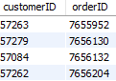

Q8. **Write a query to calculate total revenue (Sale price * Quantity) for products whose Sale price and Quantity are equal.**

Q9. **Print all product names that have sold zero quantity. Sort the names in descending order.**

Sampke Output -

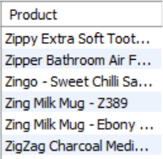

Q10. **How many points were earned by the customer with customer ID 57385, based on the company's tie-up with credit card companies?**

**According to the agreement, for every 100 rupees spent by the customer using a credit card, they receive 2 points.**

ASSIGNMENT – 8

Q1. **Identify top 10 most expensive orders.**

**Identify the customers who placed these orders.**

**Print Customer ID, First Name, Last Name and Total Order amount in the result set.**

**Sort the result set in descending order of Total Order Amount.**

**Sample Output**



Q2. **Print Order ID, Customer ID, First Name, Email and Total Order Amount for all orders placed.**

**Sort the result in ascending order of Order ID.**

**Sample Output**



Q3. **Print OrderDetailID, OrderID, Supplier Name, ProductID, and Quantity of all data points from the relevant tables.** **Sort the result in ascending order of OrderDetailID.**

Q4. **Print Order ID, Customer ID, Payment Type, and Total Order Amount for all orders paid through a card payment type.**

**Sort the result in ascending order of Order ID**

**Sample Output**



Q5. **Print pairs of supplier companies that established in the same country.**

**Print name of first company, name of second company, country name.**

**For example is company ABC and Company DEF are from India, the output will look like ABC, DEF, India.**

**Sort the result set in alphabetical order of company names in the first column and if the companyname is same then consider second company name in ascending order.**

Sample Output -



Q6. **Identify and print pairs of products which have the same sale price. Print the names of the products with same sale price in the first two columns, followed by the sale price. Filter to identify only pairs of products whose sale price is greater than 5500 bucks. Sort the result in alphabetical order of products names in the first column and alphabetical order of products names in the second column.**

Q7. **Print all customerID and OrderId where total order amount is less than 100.**

**Sort the output in increasing order of Orderid.**

**Expected Output :**



Q8. **Write a query to calculate total revenue (Sale price * Quantity) for products whose Sale price and Quantity are equal.**

Q9. **Print all product names that have sold zero quantity. Sort the names in descending order.**

Sampke Output -



Q10. **How many points were earned by the customer with customer ID 57385, based on the company's tie-up with credit card companies?**

**According to the agreement, for every 100 rupees spent by the customer using a credit card, they receive 2 points.**

ASSIGNMENT – 9

Q1. **Identify the top 5 products in terms of total quantity sold.**

**Print Product Name, Sale Price, Market Price and Total Quantity.**

**Order your output in descending order of total quantity for the same number of quantities order your output by Product.**

**Sample Output:**

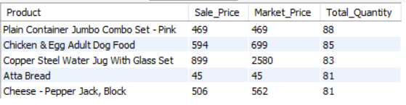

Q2. **Print Customer ID,First name,Last name,total Quantity of products ordered by them.**

**The First name of customers should start with 'a' and Last name should end with 'e'.**

**Sort the output in ascending order of Customer ID.**

Q3. **Find the total Quantity for each products whose Market price ,Quantity and Sale price are equal.**

**Print Product ID and total Quantity.**

**Sort the output in decreasing order of Product ID.**

**Sample Output**

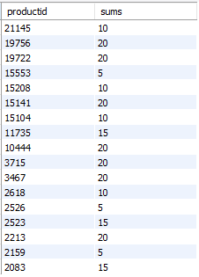

Q4. **The manager wants to know about the products sold in the year 2021 in terms of the number of customers who bought each product. Only products bought by six or more times should be included.**  
**Print the ProductID and Name of each product. Order the output in ascending order based on the ProductID.**

Sample Output -  
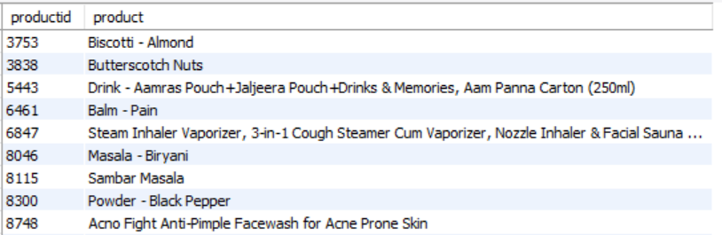

Q5. **Write a query to count of quentity for each campany name of suppliers whoes quantity are 14. Print company name ,total count and order by company name**

Q6. **Write a query to find the total Sales price for each Type of products whose Market price not equal to Sale price.**

**Sort in output in descending order of Type.**

**Sample Output**

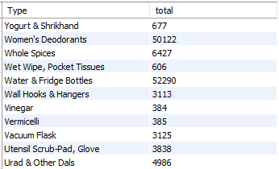

Q7. **Our company wants to know about those 5 sub categories which are sold least in terms of Sum of Total Order Amount.**

**Print Sub Category, Total Revenue generated by each Sub Category.**

Sample output:

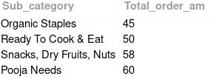

Q8. **Get the last OrderDate of all customers for each Country whose customer's Birth month is "May".**

**Sort the output in alphabetical order of Country.**

**Sample Output**

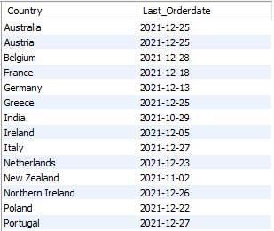

Q9. **Write a query to find the average Quantity of all suppliers for each Country.**

**Print the supplier's Country and average Quantity rounded to a scale of 2 decimal places.**

**Sort the result in descending order of average Quantity.**

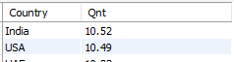

ASSIGNMENT – 10

Q1. **Get details of customers along with their total spend across the different orders they ordered.**

**Print CustomerID, FirstName, LastName and Total_Spend in the result set.**

**(Hint : for Total_Spend use Total_order_amount)**

**Order the result set in ascending order of CustomerID.**

Q2. **Print all details of the Customer who ordered only once.**

**Sample Output**

image

Q3. **Identify top 5 Cities whose customers placed the most orders.**

**Print City, State, Country, Number of Orders in the result set.**

**Sort the result set in descending order of Number of Orders.**

**Sample Output**

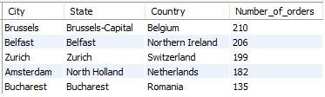

Q4. **Print CustomeriD, Customer’s First Name, Last Name, Total No of Unique Orders placed by him/her, Total Amount spent by him/her on all his/her orders combined of every customer irrespective of their ordering activity.**

**Filter your records to get customer’s whose last name contains the letter ‘m’ and who have placed more than 10 orders.**

**Sort the result set in ascending order of CustomerID.**

**Sample Output:**

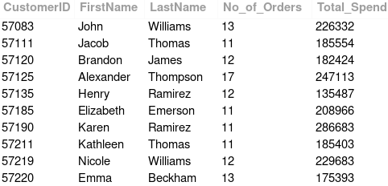

Q5. **Each order contains different bunch of products.**

**Each of these products are supplied by different suppliers.**

**Identify the orders for which one of the suppliers is from India.**

**Finally print the count of such orders placed on each individual order date.**

**Print the final output in descending order of orderdate.**

**Sample Output:**

[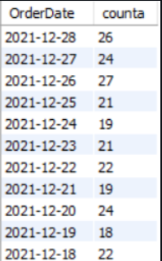](https://cp.masaischool.com/assignments/3105/pi/5/solve)

Q6. **Write a query to find the average discount percenatge for each Category.**

Discount % = ((Market Price - Sale Price)/Market Price)* 100

**Print the Category ID along with average discount percentage(Round the avg discount percentage to 2 decimals).**

**Sort the output in ascending order on CategoryId.**

**HINT: Use CTE for this question.**

**Sample Output**

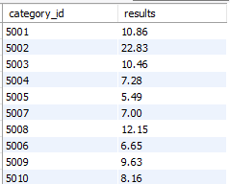

Q7. **Print all details of Products which were never ordered in any of the orders.**

**Sort the result in ascending order of ProductID.**

Required Result:

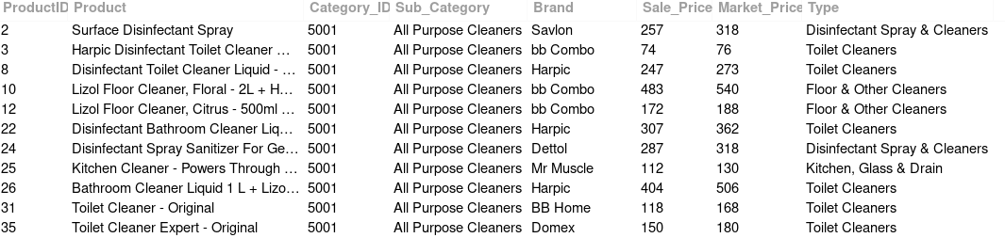

Q8. **Identify the Shippers who shipped more than or equal to 525 orders that were placed in the Year 2021.**

**Print Shipper Id, Shipper Name, and Count.**

**Hint: Use the LIKE Operator on the relevant column.**

**Sort the result in ascending order of Shipper ID.**

**Sample Output**

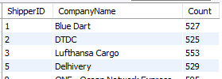

Q9. **Select the top 10 Country names and Total Revenue generated ( Using Total_order_amount ) from that Country.**

**Print Country, Total revenue**

**sort the output in decreasing order of Total Revenue.**

**Sample Output:**

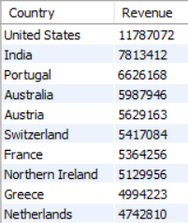

Q10. **The company wants to determine the top three product names with the highest frequency of orders, meaning the products that are most frequently ordered by customers, and print those product names as their ranking.**

Sample Output -

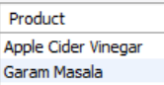

ASSIGNMENT – 10

Q1. **Write a query to find all the data from Orderdetails table whose orders were placed on 2020 and got delivered in 2021.**

**(For example, order date is 2020-12-08 and delivery date is 2021-01-04).**

**Order your output in ascending order of Orderdetails ID.**

**Solve the problem using CTEs.**

**Sample Output**

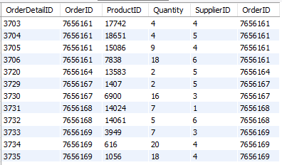

Q2. **Write a query to find the total sales price for each type of product whose market price is greater than 800.**

**Print the product type and total sales price.**

**Sort the output in descending order based on the total sales price and ascending order based on type.**

Sample Output -

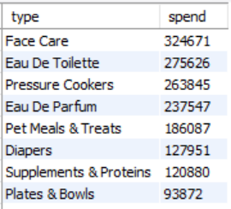

Q3. **Which product types have not been sold and what is the total number of products in each of those types?**  
**Sort the table based on the total number of unsold products in each type in descending order, and the names of the types in ascending order.**

Sample Output -

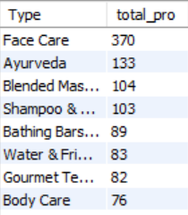

Q4. **Print all details of products whose Sale price are greater than the average Sale price.**

**Sort the output in increasing order of Product ID.**

**Sample Output**

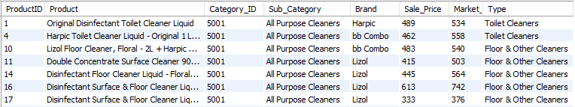

Q5. **Write a query to display all details of Orders with an amount greater than or equal to the maximum Total order amount of all customers.**

**Sort the output in increasing order of Order ID.**

**Sample Output**

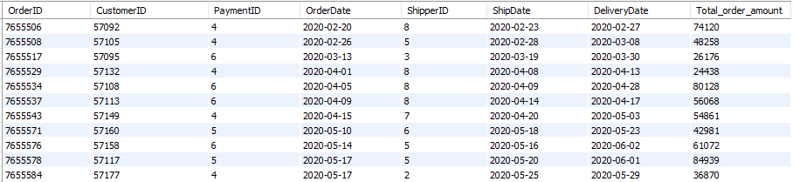

Q6. **'Find the total revenue generated through the sales of products supplied by the different countries.**

**Print Country and Revenue Generated in the descending order of Revenue.**

**Here Revenue refers to (Sale Price * Quantity).**

**Sample Output:**

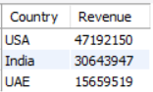

Q7. **The Company wants to analyse the popularity of different sub categories amoung the elders.**

**Elders are considerd as the person with above 60 age.Find the age from birth to the date of order.**

**Suggest the list of top 10 subcategories which are frequently purchased in the orders placed by elders.**

**Print the sub category and the number of times it is ordered in any of the orders.**

**Sort the result in descending order of number of orders.**

**Sample Output:**

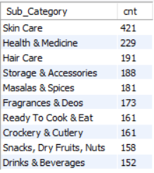

Q8. **Write a query to find the Shipper companies whose average total amount greater than 1500.**

**Sort the result in ascending order of average total amount.**

**Sample Output**

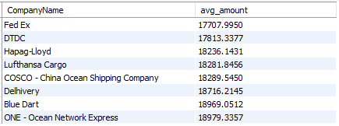

Q9. **Print the list of Firstname which are repeated in the database.**

**Order the output in ascending order of firstname.**

**Sample Output:**

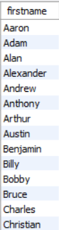

Q10. **How many orders were placed on the first day? **

**consider the lowest order date as the first day.**

**The output should be only the count of orders.**